Raymond Delgado

CIS 5560

Professor Woo

March 8, 2020

Homework 01

Lab 2C

Wind Column Chart:

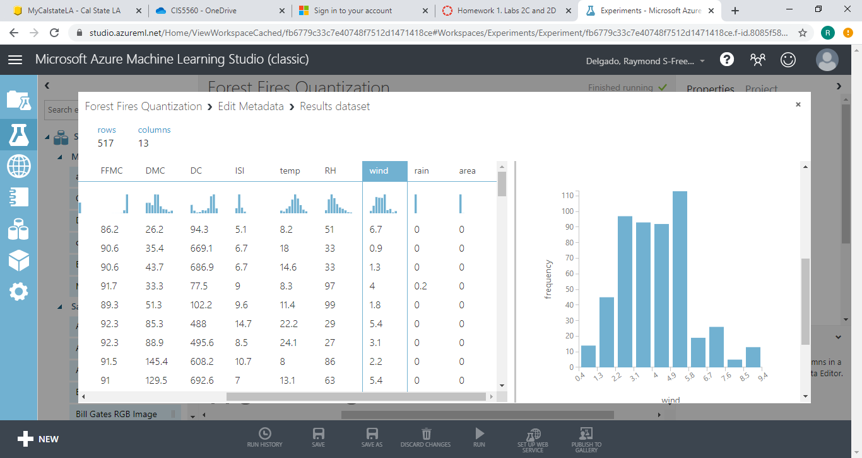

Wind_Quantized Column chart

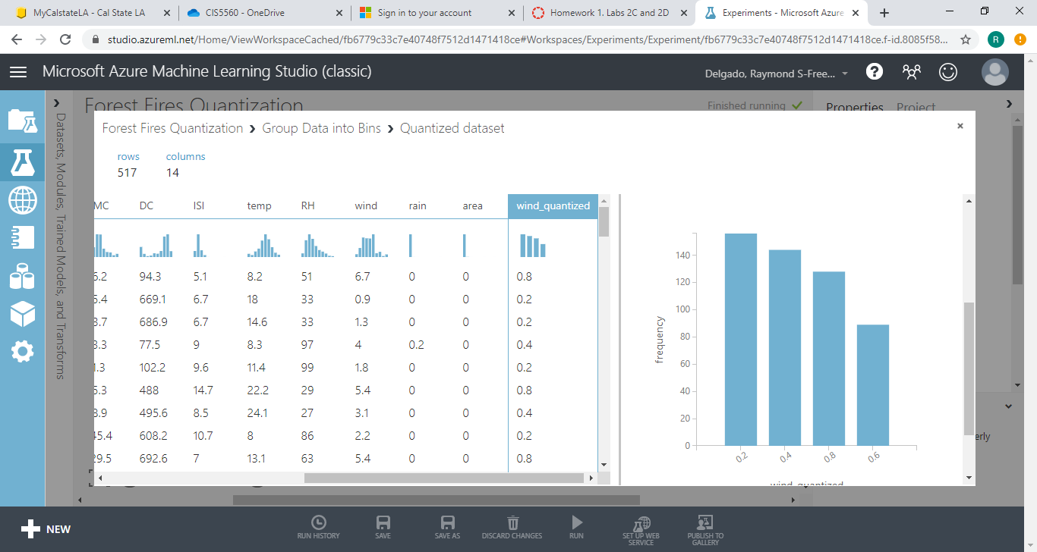

Wind_cat Column Chart

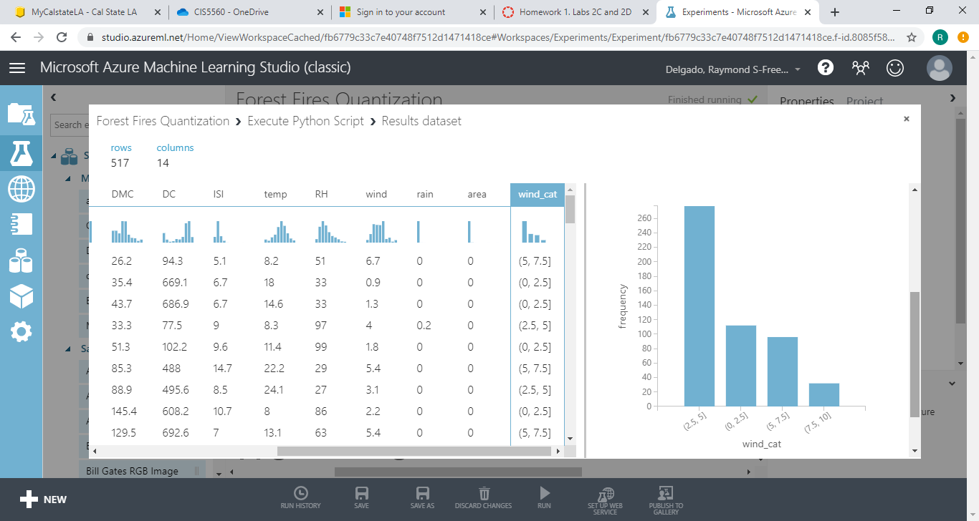

Lab 2D

Payer_code Chart and Question of # 7

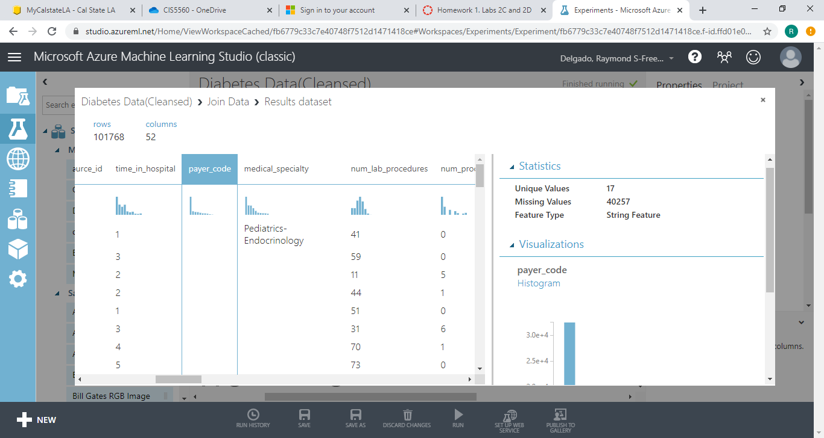

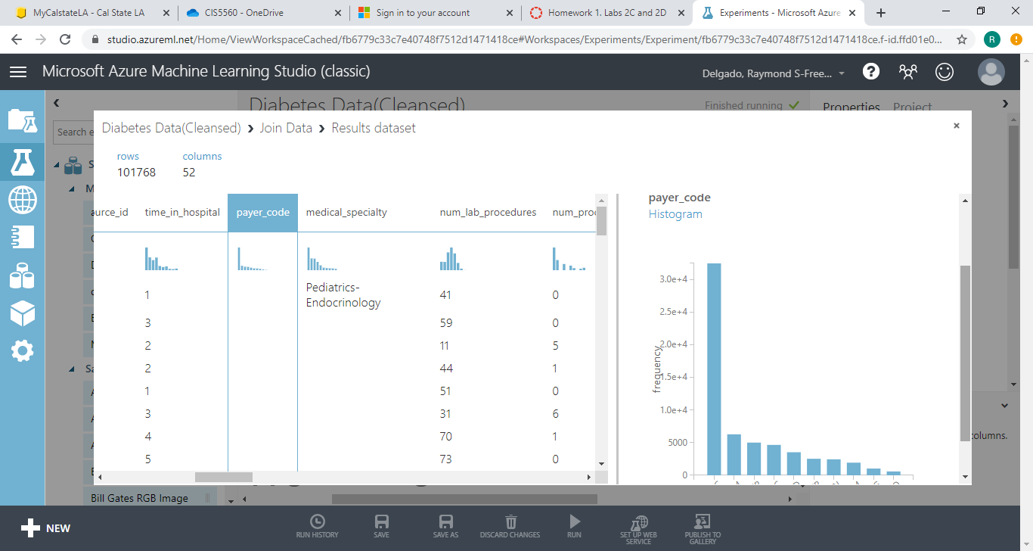

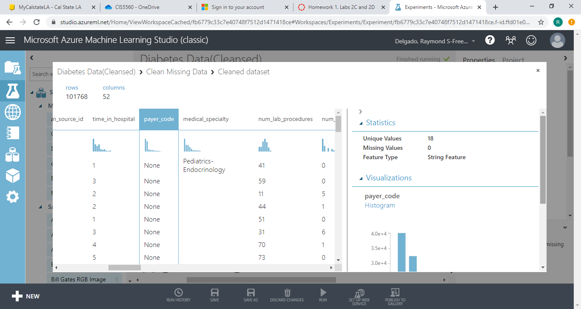

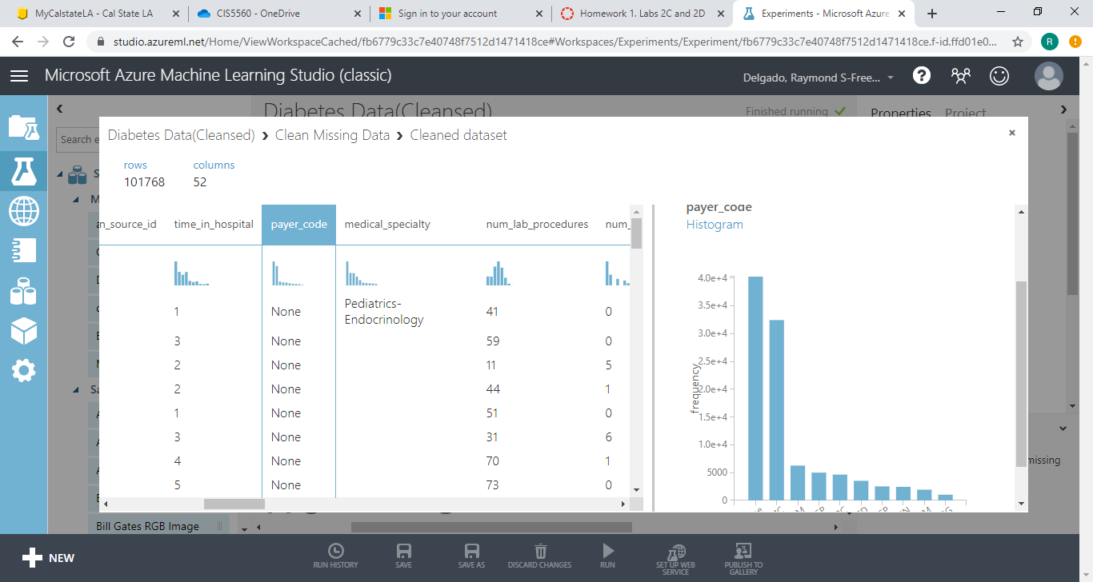

Results Dataset Output of the Remove Duplicate Row Module Showing the total number of rows has changed

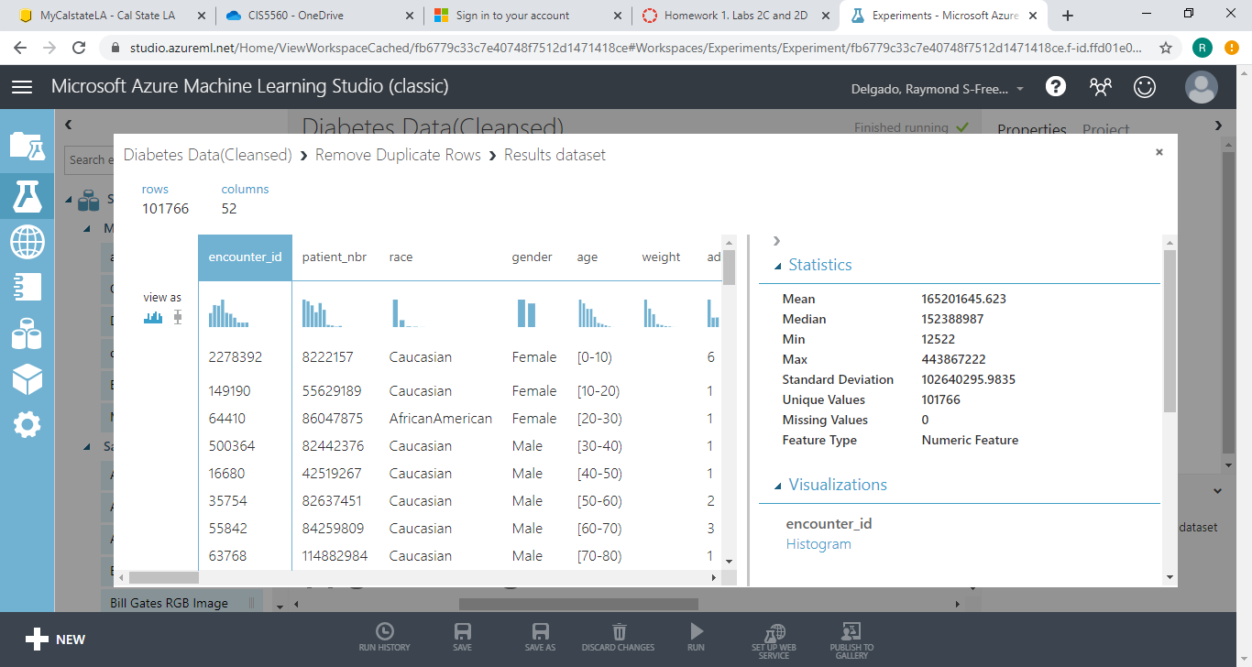

ISI Scatter Plot Chart

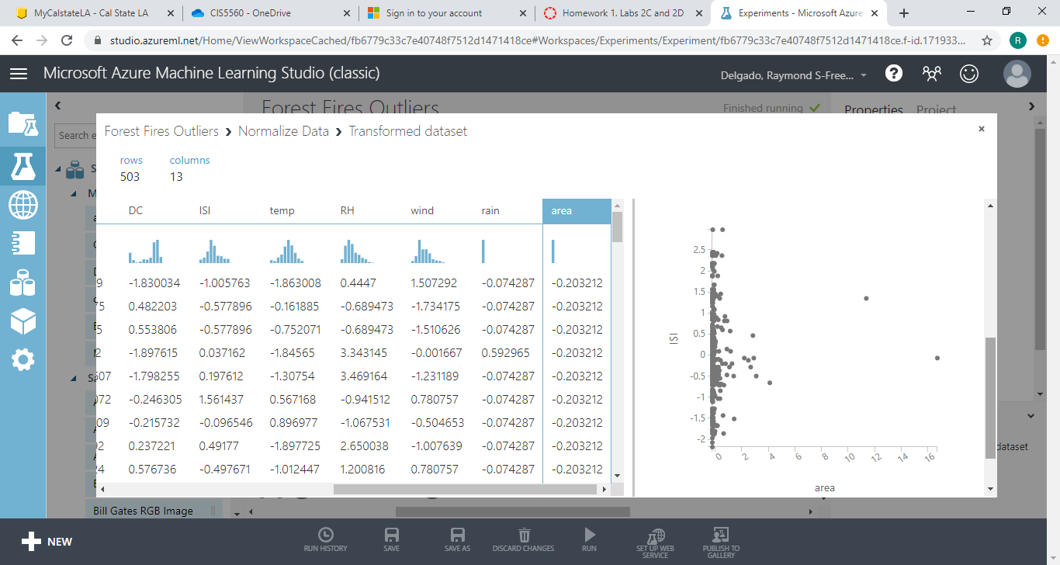

Scatter Plot Chart

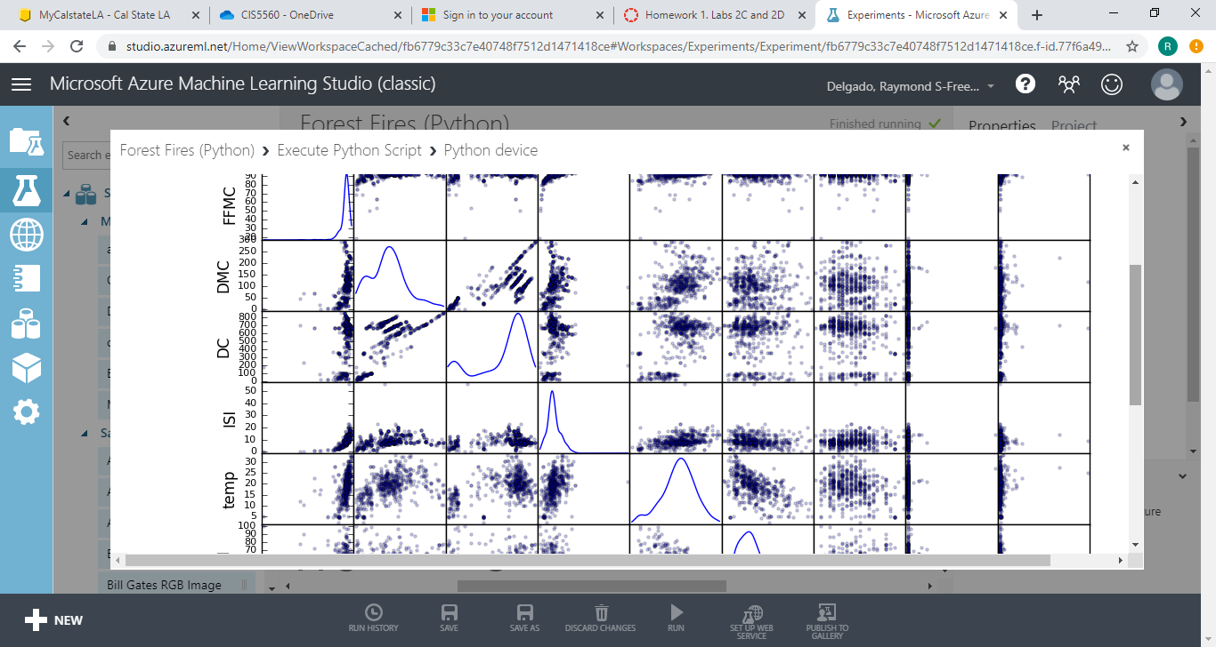

Mean, MIN, and Max statistics for the rain column

|  |  |
| --- | --- |
| **Mean** | **0.0093** |
| **Median** | **0** |
| **Min** | **0** |

